**COMET BAY COLLEGE**

**Physics Unit 3 & 4 - Task 12**

**Quantum Test**

**Name: Total Marks /59**

**Question 1:**

There are six flavours of quarks (normal matter versions).

1. Determine the charge of the following particles that are made from quarks: (2 marks)
2. Bottom Xi prime $\left(dsb\right)$
3. Kaon-plus $\left(u\overline{s}\right)$
4. What family are these two particles from? (1 mark)
5. Give an example from your studies of when a neutrino could come into existence. (2 marks)

**Question 2:**

Towards the end of the 20th century scientists suggested that quarks were the basic building blocks of protons and neutrons.

1. If a proton is made up of 3 quarks, what are the charges on each quark? (1 mark)
2. Explain your answer with reference to the charge only. (1 mark)

**Question 3:**

Pauli’s exclusion principle is an important theory to consider when considering the behaviour of orbital electron. What is Pauli’s Principle and list the four quantum numbers? (5 marks)

**Question 4:**

Tonic water contains quinine and is a clear liquid under normal lighting conditions. When UV light shines onto tonic water it starts to glow with a distinct blue colour. This is because of the process of fluorescence. One of the atoms in quinine has a ground state energy level value of -9.10 eV. It is excited to Energy Level 3 (E3) by a UV photon of wavelength 322 nm. A blue photon of wavelength 469 nm is emitted in a de-excitation from E3 to E2.

1. On the diagram below show and label the electron transitions taking place that give rise to the observed phenomenon. (2 marks)

E1

E2

E3

-9.10 eV

1. Calculate the value of Energy Levels 2 and 3 (eV) and show them on the diagram. Show your working in the space below. (4 marks)
2. Determine the wavelength (nm) of the other photon that can be emitted in this fluorescence process by a transition from E2 and state whether it is visible or not. (refer to the data sheet to justify your answer). (4 marks)

**Question 5:**

The age of the Universe is predicted to be about 14 Gy. Demonstrate, using a known method, that this is the age the Universe is predicted to be? (3 marks)

You may need to use the following data;

* H0 = 71 km/s/Mpc
* 1 pc = 3.08 x 1016 m

**Question 6:**

Feynman’s Diagrams are used in sorts to explain the interactions between particles and the interactions between sub-atomic particles.

1. Explain the diagram below and show it works using the conservation of Baryons, Leptons and Charges. (5 marks)

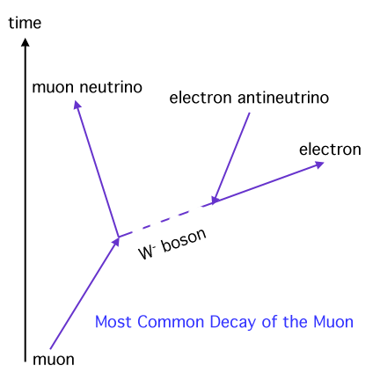

1. an electron meets a positron and they are annihilated
2. Draw a Feynman’s Diagram showing the process (2 marks)
3. Calculate the energy released when they are annihilated. (2 marks)

**Question 7:**

An apparatus used for identifying minerals in mining samples involves releasing electrons from a cathode electron gun and accelerating them across a potential difference and through a pair of parallel charged plates and then impacting with the sample. The electrons are accelerated through a potential of 35 kV, and through a distance of 330 mm between the charged plates.



1. Calculate the strength of the electric field between the charged plates. (3 marks)
2. Calculate the magnitude of the velocity of the electrons as they exit the electron gun assembly. (3 marks)
3. After leaving the electron gun assembly, the electrons travel through a uniform magnetic field which is perpendicular to their direction of motion. If the magnetic field strength is 0.300T, through what radius will the electrons be deviated? (3 marks)

**Question 8:**

The distances to galaxies can be estimated by observing Cepheid Variables within a galaxy. A Cepheid Variable is a class of star that pulsates. The relationship between the period of pulsation and the size of the star is very precise. An understanding of how brightness diminishes with distance allows astronomers to estimate distances to galaxies with a high degree of confidence.

The following data was recorded by the Hubble Space Telescope for five galaxies.

|  |  |  |
| --- | --- | --- |
| Distance  (Mpc) | Red shift - z | Recessional speed of galaxy vgalaxy (km s-1) |
| 3.1 | 0.00095 | 285 |
| 8.6 | 0.00212 |  |
| 12.2 | 0.00273 |  |
| 16.1 | 0.00402 |  |
| 19.4 | 0.00473 |  |

1. Fill in appropriate values in the final column of the table (the first value has been done for you) (2 marks)
2. Plot a correctly labelled graph of recessional speed versus distance to galaxy on the graph paper and draw a line of best fit . (4 marks)

graph paper C whirlygig 8 by 10

1. Calculate a value for Hubble’s constant, in the correct units, showing how you obtained this value from your graph. (3 marks)
2. State three reasons why you think that measurements of Hubble’s constant have varied widely since Hubble’s first determination in 1920. (3 marks)

**Question 9:**

|  |  |
| --- | --- |
| **Particle** | **Quarks** |
| Kaon-minus |  |
| Pi-plus (π+) |  |
| Sigma-plus |  |
| Lambda-zero |  |
| Charmed Omega |  |

There are six flavours of quarks (normal matter versions) and six flavours of antiquarks. A combination of these quarks and antiquarks form particles similar to those commonly known – protons and neutrons. To the right is a table showing other such particles and their quark combinations.

1. Determine the charge (coulombs) of the Lambda-zero: (1 mark)
2. Determine the charge (coulombs) of the Kaon-minus: (1 mark)
3. Briefly explain why quarks of like charge are not repelled from each other in a hadron.

(2 marks)